# Python web design 2025/5/8

* Currently in our class, we create a file folder for each day. The created folder is a project.
* Try to create a Python space in Perplexity. It will keep the questions you asked in the space for later check.
* Lib/random.py, .py file includes the sample() function.
* If there is ‘*’ inside the function, this means the parameter after the ‘*’ must use 參數值名稱 (keyword argument)
* The third party open source Python packages. Visit Pypi.org website.
* Ask Perplexity   
  我要使用Python open source, 目的是下載網路上的檔案，有建議使用哪一個module嗎?

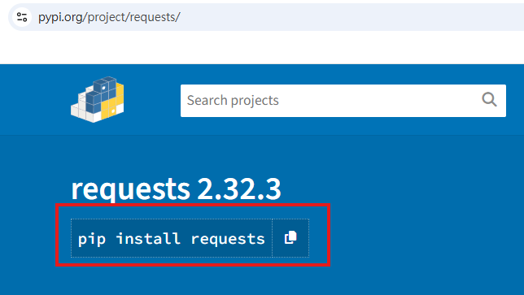

* Python package installation.



* All modules need to use ‘import’ command to use their functions
* Generally, you can get the data from property only.

Install miniConda

**conda**

## 安裝mini conda

* <https://docs.anaconda.com/free/miniconda/index.html>

### 取消termail一開始就進入base虛擬環境

conda config --set auto_activate_base false

### conda init

conda init --all bash

### conda版本檢查

conda -V

### conda更新

conda update conda

### 檢查目前已建立的虛擬環境

conda env list

### 建立虛擬環境

conda create --name myenv python=3.10

### 啟動虛擬環境

conda activate myenv

### 離開虛擬環境

conda deactivate

### 安裝套件

conda activate myenv

conda install matplotlib

conda install --name myenv matplotlib

### 安裝requirement.txt

conda install --yes --file requirements.txt

### 檢查目前安裝的套件

conda list

### 刪除虛擬環境

conda env remove --name myenv

### 刪除虛擬環境的套件

conda remove --name myenv matplotlib